Software Requirements Specification
For Digital Campus

Votary Softech Solutions Pvt. Ltd.
Plot No: 76, Lumbini layout,
Near Euro school,
Gachibowli-I (V), Hyderabad,
Telangana - 500032,
India.

Define
Digital Campus has capabilities to detect employee ble/BT tag location through standalone gateways, In-time out-time, Dwell times of employee

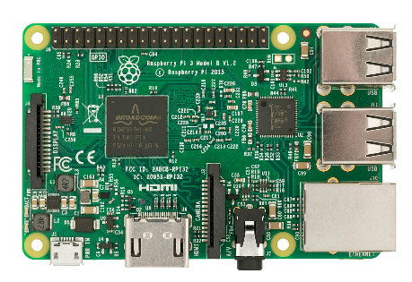





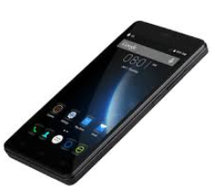
Ethernet/WiFi
Cloud

User Application
Gateway

Scope
Purpose of this project is to locate, track employee through ble/BT tag and to get hands on experience to Engineer’s from LC on a project life cycle

Functional Requirement’s

SL # | Requirements | Description
1 | REQ - DC001 | User can locate last known/Current location of employee
2 | REQ – DC002 | User can query In/Out time of employee
3 | REQ – DC003 | User can get Dwell Time of Employee
4 | REQ – DC004 | User can get number of employee’s by gateway

Technical Requiements’s

SL # | Requirements | Description
1 | REQ - DC001 | Gateway should able to detect,filter nearby ble/BT
2 | REQ – DC002 | Gateway should scan continuously for  ble/bt devices
3 | REQ – DC003 | Gateway should able to detect upto 100  ble/bt devices
4 | REQ – DC004 | Gateway should able to send ble/BT details  to remote database at every 2 seconds
5 | REQ – DC005 | Database should store the received details  and provide the data accessible to User application
6 | REQ – DC006 | User application should able to perform all  the defined functional requirement’s

Assumptions
Employee’s carry ble/BT tags

